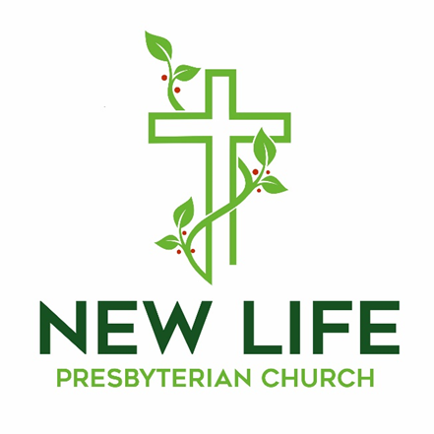

**Embrace God’s Beauty; Extend God’s Love**

**Welcome to New Life Presbyterian Church**

Dear Visitor,

Welcome! It is a joy and privilege to gather this morning to worship God together. Here at New Life, we are a small part of the worldwide, multi-ethnic, multi-generational, multi-cultural body of Christ. Although we are Presbyterian and Reformed, our identity is found not in what makes us distinct, but in what makes us united: we belong to the Lord Jesus Christ. He is not only our Maker; He is our Savior. If you have put your hope and trust in Him, we welcome you as a brother or sister. It is in Him that we have New Life!

If you are here this morning and do not know what you think about Jesus, or about the claims of the Bible, we are delighted that you have chosen to join us for the morning. We hope and trust that you will experience a warm welcome, regardless of your religious convictions. We are a community of those who have experienced the embrace of God, through Jesus Christ. It is our goal to show that love to all who are around us. Please know that I personally would welcome your thoughts and perspectives on anything you observe this morning.

May the grace and peace of Christ be with you all!

Joyfully,



Pastor Erik Swanson

P.S. Due to COVID 19 concerns, for the time being there is no nursery. When it is wise and practical, we will resume our nursery. Parents are encouraged to bring their children to worship. Even as children and parents may need to use the backspace of the sanctuary to move around, the church rejoices in the blessing that families are!

**Worshiping God**

June 28, 2020

**Reflection:**

*“The church is constituted as a new people who have been gathered from the nations*

*to remind the world that we are in fact one people. Gathering, therefore, is an eschatological act as it is the foretaste of the unity of the communion of the saints.”*

*―* Stanley Huerwas

**Prelude**

**Welcome and Announcements** *Erik Swanson*

**Call to Worship –** *Jeremiah 10:6-7*

6There is none like you, O Lord; you are great, and your name is great in might.

7Who would not fear you, O King of the nations? For this is your due; for among all the wise ones of the nations and in all their kingdoms there is none like you.

**Prayer of Praise**

**O Praise the Name (Anástasis)**

***Verse 1***

I cast my mind to Calvary,

Where Jesus bled and died for me.

I see His wounds, His hands, His feet,

My Saviour on that cursed tree.

***Verse 2***

His body bound and drenched in tears,

They laid Him down in Joseph's tomb.

The entrance sealed by heavy stone,

Messiah still and all alone.

***Chorus***

O praise the Name of the Lord our God,

O praise His Name forevermore.

For endless days we will sing Your praise,

Oh Lord oh Lord our God.

***Verse 3***

Then on the third at break of dawn,

The Son of heaven rose again.

O trampled death where is your sting?

The angels roar for Christ the King.

***Verse 4***

He shall return in robes of white,

The blazing sun shall pierce the night.

And I will rise among the saints,

My gaze transfixed on Jesus' face.

**Confession of Faith –** *From the Westminster Confession of Faith, chapter 8*

**God was pleased, in his eternal purpose, to choose and ordain the Lord Jesus, his only begotten Son, to be the mediator between God and human beings. As the mediator, he is the prophet, priest, and king, the head and Savior of His church, the heir of all things,**

**and the judge of the world. God gave to him, from all eternity, a people to be His seed and to be by him, in time, redeemed, called, justified, sanctified, and glorified. The Lord Jesus, by his perfect obedience and sacrifice of himself—which he through the eternal Spirit once offered up to God—has fully satisfied the justice of his Father. He purchased not only reconciliation but also an everlasting inheritance in the kingdom of heaven for all those whom the Father has given to Him.**

**NT Scripture Reading:** *Acts 1:6-11 Joy Swanson*

*Reader: This is the word of the Lord.*

**All: Thanks be to God!**

**Prayer of Confession:**

**O Lord, no day of our lives passes that does not prove us guilty in your sight. Our best services are filthy rags. All things in us call for our rejection. However, all things in Christ plead our acceptance. Grant us to hear your voice assuring us that by your wounds we are healed, that you were bruised for our iniquities, that you became sin for us that we might become righteous in you. Grant that by resting in your righteousness we may hereafter walk in newness of life and live in obedience to your commandments. Through Jesus Christ our Lord. Amen.**

**Assurance of Grace –** *Psalm 32:1-2,5*

*Leader:*  1Blessed is the one whose transgression is forgiven, whose sin is covered.

2Blessed is the man against whom the Lord counts no iniquity, and in whose

spirit there is no deceit. 5I acknowledged my sin to you, and I did not cover

my iniquity; I said, “I will confess my transgressions to the Lord,” and you

forgave the iniquity of my sin.

**My Hope is Built on Nothing Less**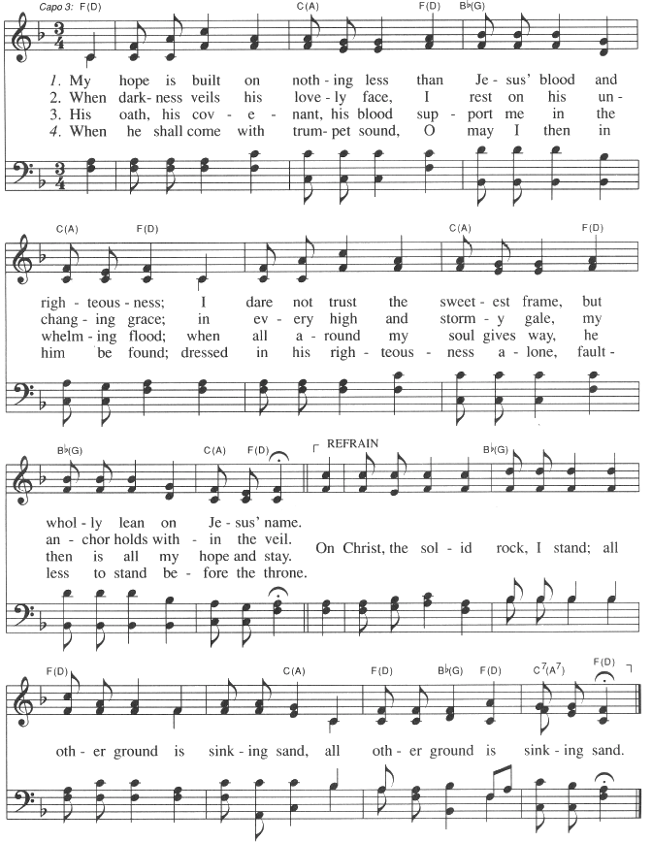

**Prayers of the People**

**Ministry Moment**

**Offering Our Gifts**

The offering allows friends and members of our church to express their faith in God’s Word, and to support the extension of that Word in our community and world.

**Doxology** Praise God from whom all blessings flow!

Praise Him, all creatures here below!

Praise Him above, ye heavenly host!

Praise, Father, Son, and Holy Ghost!

Amen.

**Scripture Reading -** *Psalm 11*

1In the LORD I take refuge; how can you say to my soul, “Flee like a bird to your mountain,

2for behold, the wicked bend the bow; they have fitted their arrow to the string to shoot in the dark at the upright in heart; 3if the foundations are destroyed, what can the righteous do?” 4The LORD is in his holy temple; the LORD’s throne is in heaven; his eyes see, his eyelids test the children of man. 5The LORD tests the righteous, but his soul hates the wicked and the one who loves violence. 6Let him rain coals on the wicked; fire and sulfur and a scorching wind shall be the portion of their cup. 7For the LORD is righteous; he loves righteous deeds; the upright shall behold his face.

**Sermon: The Lord on His Throne** *Rev. Erik Swanson*

**Series: Desiring God**

**Sermon Notes**

### 

**Celebration of Holy Communion**

**New Life Church invites all baptized Christians who are members of Christ’s church to join us in this feast of bread and wine. The inner circle of cups contains red wine and the outer circle of cups contains white grape juice. If you are unable to consume wheat, gluten free crackers are available.**

**Prayer**

**Words of Institution – From I Corinthians 11**

**Leader: Let us proclaim the mystery of the faith.**

**All: Christ has died.**

**Christ has risen.**

**Christ will come again.**

**Communing Together**

**Rows will be dismissed to come up front to receive communion. Please hold each element until all have received it. After you have received the bread, we will partake of it together; after you have received the cup, we will partake of it together.**

**Prayer of Thanksgiving**

**Thy Mercy, My God**

***Verse 1***

Thy mercy, my God is the theme of my song,

The joy of my heart and the boast of my tongue.

Thy free grace alone from the first to the last,

Hath won my affections and bound my soul fast.

***Verse 2***

Without Thy sweet mercy I could not live here,

Sin would reduce me to utter despair.

But through Thy free goodness my spirits revive,

And He that first made me still keeps me alive.

***Verse 3***

Thy mercy is more than a match for my heart,

Which wonders to feel its own hardness depart.

Dissolved by Thy goodness I fall to the ground,

And weep for the praise of the mercy I found.

***Chorus***

Halleluiah (halleluiah halleluiah)

***Verse 4***

Great Father of mercies Thy goodness I own,

And the covenant love of Thy crucified Son.

All praise to the Spirit whose whisper divine,

Seals mercy and pardon and righteousness mine.

All praise to the Spirit whose whisper divine,

Seals mercy and pardon and righteousness mine.

**Benediction –** *Numbers 6:24-26*

*Leader:* 24The Lord bless you and keep you; 25the Lord make his face to shine upon you and be gracious to you; 26the Lord lift up his countenance upon you and give you peace.

**The Sending**

*Leader: Go in peace to love and serve the Lord.*

**All: Thanks be to God!**

**Postlude**

---------------------------------------------------------------------------------------------------------------------

*All songs are either public domain or licensed under CCLI #2410623.

**This Week at New Life**

|  |  |  |  |
| --- | --- | --- | --- |
| **Date** | **Time** | **Event** | **Location** |
| Sun, 6/28 | 9:00 AM | Adult Sunday School Class Becoming Whole | Fellowship Hall |
| Sun, 6/28 | 10:00 AM | Corporate Worship | Sanctuary |
| Sun, 6/28 | 11:45 AM | Congregational Meeting | Sanctuary |
| Thur, 7/2 | 8:00 PM | College and Career Ages Meeting | Homes via Zoom |
| Sun, 7/5 | 9:00 AM | Adult Sunday School Class Becoming Whole | Fellowship Hall |
| Sun, 7/5 | 10:00 AM | Corporate Worship | Sanctuary |

**Church Financial Summary (giving through June 14)**

|  |  |  |
| --- | --- | --- |
| **Category** | **Budget** | **Actual** |
| **Year to Date Offering** | $96,000.00 | $95,702.53 |
| **Last Week** | $4,000.00 | $4,473.00 |

**Announcements**

* ***Deacon Candidate and Congregational Meeting:*** The session is pleased to announce those deacon candidates eligible for a congregational vote. The candidates are Leon Leader, Blaine Marsh, and Iren Snavely. The session is calling for a congregational meeting today at 11:45 AM. The purpose of this meeting is for the congregation to vote in regards to the above deacon candidates.
* ***SILVERS Event:*** Please join us on July 18 at Steve and Suzanne Harman’s home to watch and learn about the butterflies in Steve’s flower gardens. We will begin at 11:00 am and will be sharing lunch together. Each couple or single please bring a finger food dish to share with either tooth picks, tongs, etc. to serve your food. Please sign up at the Communications Table. Rain date will be July 25.
* ***New Address:*** Doug and Deb Redding’s new address is 5 Hidden Springs Lane Taylors, SC 29687
* ***New Attendees Dinner:*** Whether you have been attending New Life for one week or one year, you are invited to join the New Attendees Dinner. Please come to Marlene Spark's home (335 Salem Court), any time after 5:00 on July 24th, with dinner being served at 5:30. Rain date will be July 25th.
* ***Ultimate Frisbee:*** Meet at York Township park on the third Sunday of the month at 3:00, for a game of ultimate frisbee.
* ***Spain Missions Trip Cancellation:*** Due to COVID complications, this summer's trip is cancelled.
* ***VBS Canceled***: Due to COVID complications, this summer’s VBS is cancelled.
* ***Summer Book Club:*** At the end of August we will be discussing, "Leaving Buddha", by Tenzin Lahkpa. Books are available at amazon for $9.99-kindle version, or for $10.99 paperback at both amazon and Christianbook.com. Feel free to invite anyone you know of who might be interested in joining us.
* ***Worship Service Options:*** All are invited to attend in person at New Life. The service will be live streamed via YouTube on the church website home page. Click the livestream button. PDF’s of the bulletin will be available for download. They may be found under the sermons tab. Click on the title that lists that service date, and the bulletin is there as a download. The complete service will be available on the church website, under the sermons tab, as well as on the church Facebook page. A CD will be burned and distributed to those who request it.
* ***Small Group Ministries Resuming:*** In keeping with the allowances in the "green" status of York County, all NLPC small groups (ministry teams, bible studies, prayer groups, discipleship groups, community groups, etc.) are encouraged to resume meeting. If using the building, ministry leaders should wipe down door handles and light switches used by their group. In addition, masks are strongly recommended, social distancing should be observed, and meeting outdoors as much as is practical is recommended. Finally, it is fine for groups to continue to meet online if the groups prefer that.

**Ongoing Groups for Fellowship and Growth**

* ***Christian Education:*** Adult Sunday School Class will take place in the Fellowship Hall at 9:00 am.
* ***Wednesday Morning Bible Study:*** Postponed
* ***Thursday Morning “Mom’s Group” Bible Study:*** Contact Joy Swanson for more information.
* ***Men’s Group:*** Contact Rob Rothermel for more information.
* ***Women’s Bible Study:*** Resuming in the fall.Contact Marlene Spark for more information.
* ***Youth Group:*** Please contact the church office for more information.
* ***Second Sunday Lunch***: Postponed
* ***Prayer Small Group:*** Contact Sue Rothermel for more details.
* ***Bible Study Fellowship (BSF):*** Summer recess. Resuming in September with a study of Genesis.

**New Life Presbyterian Church Vision, Mission, and Core Values**

**Vision: *To see York and beyond embrace God’s beauty and extend God’s love.***

**Mission: *To receive the grace of God, to give the glory to God,***

***and to follow the Word of God.***

**Core Values:**

* **His Voice**: While God speaks through creation, God speaks directly in the

Word of God. Therefore, we receive and obey God’s Word.

* **His Plan:** Because God is love, God is on a mission to save. We seek to

follow Him in His mission.

* **His Grace:** The good news for sinners is that Jesus saves, by grace. Through

faith we believe in Christ and grow in Christ.

* **His Power:** Only God has power to save and sustain His people. We depend

on the Holy Spirit.

* **His People:** In Christ, the church is made one. In the midst of both unity and

diversity, we must love one another.

* **His Gifts:** Creation, redemption, and the ability to serve are all gifts from

God. The entire church should be equiped and empowered to

serve gratefully.

* **His Timing:** All things are in God’s hands. Therefore, we trust in His ways.

For more information, please visit: http://www.newlifeyorkpca.com/about-us.html

**New Life Presbyterian Church, (717) 855-2360**

**970 Cape Horn Rd., York, PA 17402**

**admin@newlifeyorkpca.com**