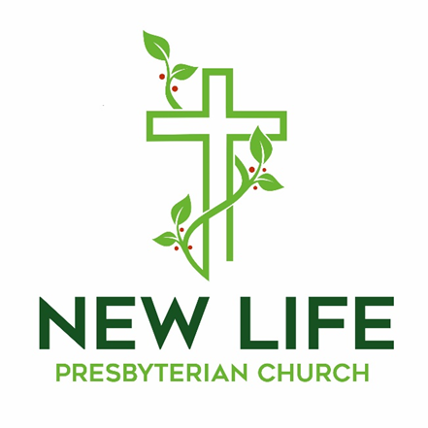

**Embrace God’s Beauty; Extend God’s Love**

**Welcome to New Life Presbyterian Church**

Dear Visitor,

Welcome! It is a joy and privilege to gather this morning to worship God together. Here at New Life, we are a small part of the worldwide, multi-ethnic, multi-generational, multi-cultural body of Christ. Although we are Presbyterian and Reformed, our identity is found not in what makes us distinct, but in what makes us united: we belong to the Lord Jesus Christ. He is not only our Maker; He is our Savior. If you have put your hope and trust in Him, we welcome you as a brother or sister. It is in Him that we have New Life!

If you are here this morning and do not know what you think about Jesus, or about the claims of the Bible, we are delighted that you have chosen to join us for the morning. We hope and trust that you will experience a warm welcome, regardless of your religious convictions. We are a community of those who have experienced the embrace of God, through Jesus Christ. It is our goal to show that love to all who are around us. Please know that I personally would welcome your thoughts and perspectives on anything you observe this morning.

May the grace and peace of Christ be with you all!

Joyfully,



Pastor Erik Swanson

P.S. Due to COVID 19 concerns, for the time being there is no nursery. When it is wise and practical, we will resume our nursery. Parents are encouraged to bring their children to worship. Even as children and parents may need to use the backspace of the sanctuary to move around, the church rejoices in the blessing that families are!

**Worshiping God**

May 31, 2020

**Reflections:**

*“I've built walls, a fortress deep and mighty, that none may penetrate. I have no need of friendship, friendship causes pain. It's laughter and it's loving I disdain. I am a rock. I am an island.”* -Simon and Garfunkle

*“No man is an island entire of itself; every man is a piece of the continent, a part of the main; if a clod be washed away by the sea, Europe is the less, as well as if a promontory were, as well as any manner of thy friends or of thine own were; any man's death diminishes me, because I am involved in mankind. And therefore never send to know for whom the bell tolls; it tolls for thee.” -* John Donne

*“Let us make man in our image.”* – The Triune God

**Prelude**

**Welcome and Announcements**

**Call to Worship –** *from Deuteronomy 6 and Psalm 34 Erik Swanson*

*Minister: Hear, O Israel: The LORD our God, the LORD is one. Love the LORD your God with all your heart and with all your soul and with all your strength.*

***People: I will extol the LORD at all times; his praise will always be on my lips.***

*Minister: My soul will boast in the LORD; let the afflicted hear and rejoice.*

***People: Glorify the LORD with me; let us exalt his name together.***

**Prayer of Praise**

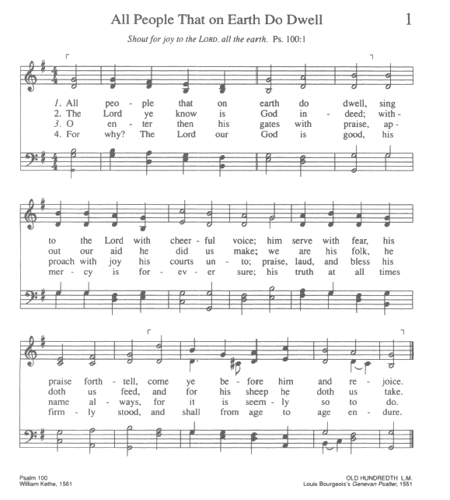

**Confession of Faith –** *The**Apostle’s Creed:*

**I believe in God, the Father Almighty, Creator of Heaven and earth; and in Jesus Christ, His only Son Our Lord, who was conceived by the Holy Spirit, born of the Virgin Mary, suffered under Pontius Pilate, was crucified, died, and was buried. He descended into Hell; the third day He rose again from the dead; He ascended into Heaven, and sitteth at the right hand of God, the Father almighty; from thence He shall come to judge the living and the dead. I believe in the Holy Spirit, the holy Catholic Church, the communion of saints, the forgiveness of sins, the resurrection of the body and life everlasting. Amen.**

**NT Scripture Reading:** *Hebrews 3:12-4:1 Blaine Marsh*

*Reader: This is the word of the Lord.*

**All: Thanks be to God!**

**Prayer of Confession:**

**Gracious God,**

**You have redeemed us through Jesus Christ our Lord. We belong to you. Yet we confess that we are quick to forget your work of redemption. We are slow in remembering what you have done. When we forget, we go our own way. We live in fear and pride rather than living in trust and humility. In failing to remember, we both sin against you and we harm others. Have mercy, we pray. We call to mind your mighty deeds of redemption. We remember our Lord’s life, his sacrificial death, and his glorious resurrection. We remember that you have given your Spirit. Help us, we pray, to remember daily what you have done, so that we might walk in the freedom which you have purchased for us. This we pray, through Jesus Christ our Lord, amen!**

**Assurance of Grace –** *Zephaniah 3:16b-17*

*Leader:*  16b“Fear not, O Zion; let not your hands grow weak. 17The LORD your God is in your midst, a mighty one who will save; he will rejoice over you with gladness; he will quiet you by his love; he will exult over you with loud singing.

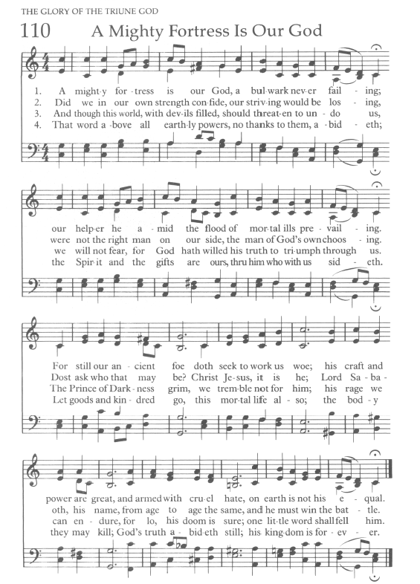

**Prayers of the People**

**Ministry Moment**

**Offering Our Gifts**

The offering allows friends and members of our church to express their faith in God’s Word, and to support the extension of that Word in our community and world.

**Doxology** Praise God from whom all blessings flow!

Praise Him, all creatures here below!

Praise Him above, ye heavenly host!

Praise, Father, Son, and Holy Ghost!

Amen.

**Scripture Reading -** *1 Corinthians 12:12-27*

[12](http://biblehub.com/1_corinthians/12-12.htm)For just as the body is one and has many members, and all the members of the body, though many, are one body, so it is with Christ. [13](http://biblehub.com/1_corinthians/12-13.htm)For in one Spirit we were all baptized into one body—Jews or Greeks, slaves or free—and all were made to drink of one Spirit.[14](http://biblehub.com/1_corinthians/12-14.htm)For the body does not consist of one member but of many. [15](http://biblehub.com/1_corinthians/12-15.htm)If the foot should say, “Because I am not a hand, I do not belong to the body,” that would not make it any less a part of the body. [16](http://biblehub.com/1_corinthians/12-16.htm)And if the ear should say, “Because I am not an eye, I do not belong to the body,” that would not make it any less a part of the body. [17](http://biblehub.com/1_corinthians/12-17.htm)If the whole body were an eye, where would be the sense of hearing? If the whole body were an ear, where would be the sense of smell? [18](http://biblehub.com/1_corinthians/12-18.htm)But as it is, God arranged the members in the body, each one of them, as he chose. [19](http://biblehub.com/1_corinthians/12-19.htm)If all were a single member, where would the body be? [20](http://biblehub.com/1_corinthians/12-20.htm)As it is, there are many parts, yet one body. [21](http://biblehub.com/1_corinthians/12-21.htm)The eye cannot say to the hand, “I have no need of you,” nor again the head to the feet, “I have no need of you.” [22](http://biblehub.com/1_corinthians/12-22.htm)On the contrary, the parts of the body that seem to be weaker are indispensable, [23](http://biblehub.com/1_corinthians/12-23.htm)and on those parts of the body that we think less honorable we bestow the greater honor, and our unpresentable parts are treated with greater modesty, [24](http://biblehub.com/1_corinthians/12-24.htm)which our more presentable parts do not require. But God has so composed the body, giving greater honor to the part that lacked it, [25](http://biblehub.com/1_corinthians/12-25.htm)that there may be no division in the body, but that the members may have the same care for one another. [26](http://biblehub.com/1_corinthians/12-26.htm)If one member suffers, all suffer together; if one member is honored, all rejoice together. [27](http://biblehub.com/1_corinthians/12-27.htm)Now you are the body of Christ and individually members of it.

**Sermon: Desiring God in Community** *Rev. Erik Swanson*

**Series: Desiring God**

**Sermon Notes**

### 

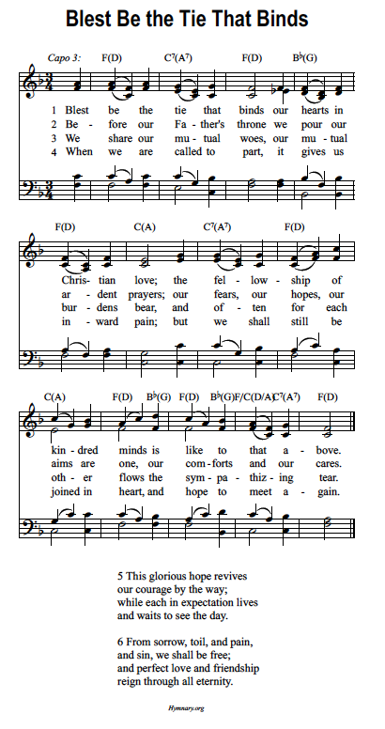

**Benediction –** *1 Thessalonians 5:23-24*

*Leader:* [23](http://biblehub.com/1_thessalonians/5-23.htm)Now may the God of peace himself sanctify you completely, and may your whole spirit and soul and body be kept blameless at the coming of our Lord Jesus Christ. [24](http://biblehub.com/1_thessalonians/5-24.htm)He who calls you is faithful; he will surely do it.

**The Sending**

*Leader: Go in peace to love and serve the Lord.*

**All: Thanks be to God!**

**Postlude**

---------------------------------------------------------------------------------------------------------------------

*All songs are either public domain or licensed under CCLI #2410623.

**This Week at New Life**

|  |  |  |  |
| --- | --- | --- | --- |
| **Date** | **Time** | **Event** | **Location** |
| Sun, 5/31 | 10:00 AM | Corporate Worship | Sanctuary |
| Sun, 5/31 | 7:00 PM | Adult Sunday School/Christian Ed Class | Homes via Zoom |
| Thur, 6/4 | 8:00 PM | College and Career Ages Meeting | Homes via Zoom |
| Sun, 6/7 | 10:00 AM | Corporate Worship | Sanctuary |
| Sun, 6/7 | 7:00 PM | Adult Sunday School/Christian Ed Class | Homes via Zoom |

**Church Financial Summary**

|  |  |  |
| --- | --- | --- |
| **Category** | **Budget** | **Actual** |
| **Year to Date Income** | $84,000.00 | $79,099.53 |
| **Last Week** | $4,000.00 | $5,110.00 |

**Announcements**

* ***Deacon Candidate and Congregational Meeting:*** The session is pleased to announce those deacon candidates eligible for a congregational vote. The candidates are Leon Leader, Blaine Marsh, and Iren Snavely. The session is calling for a congregational meeting at 11:45 AM on Sunday, June 28th. The purpose of this meeting is for the congregation to vote in regards to the above deacon candidates. Should any of you have questions about the process, a copy of the relevant portion of our Book of Church Order (Chapter 24) is available in the information center. Please continue to pray for God’s guidance in this process.
* ***Offering for the Diaconate:*** On June 7th, an additional special offering will be taken for the deacon’s fund. Contact the church office for a copy of the letter which was distributed regarding that offering.
* ***Missions Team Member Needed:*** The Missions Team is looking for one more congregant who will assist them in the work of the committee. The team selects missionaries for NLPC support, and the team prays regularly for the missionaries and seeks to encourage congregational support of missions. See Marlene Spark for more details.
* ***Worship Service Options:*** All are invited to attend in person at New Life. The service will be live streamed via YouTube on the church website home page. Click the livestream button. PDF’s of the bulletin will be available for download. They may be found under the sermons tab. Click on the title that lists that service date, and the bulletin is there as a download. The complete service will be available on the church website, under the sermons tab, as well as on the church Facebook page. A CD will be burned and distributed to those who request it.
* ***Worship Service CD Creation and Distribution Needed:*** A volunteer is needed to burn the CD of the service. The goal is to do this as soon as the sermon is uploaded, so that these CD’s can be dropped off on the drive home from church. Volunteers are needed to drop off CD’s of the service. Please contact Pastor Erik if you are willing to help.

**Ongoing Groups for Fellowship and Growth**

* ***Christian Education:*** Adult Sunday School Class, Sunday Evenings at 7:00 PM via Zoom. <https://us02web.zoom.us/j/131066007?pwd=MElmb3dOV3NrN2x1QVQzK0Z4VFYvUT09>

Phone: (301) 715 8592 Meeting ID: 131 066 007 Password: 383366

* ***Wednesday Morning Bible Study:*** Postponed
* ***Thursday Morning “Mom’s Group” Bible Study:*** Contact Joy Swanson for more information.
* ***Men’s Group:*** Contact Rob Rothermel for information.
* ***Women’s Bible Study:*** Contact Marlene Spark for more information.
* ***Youth Group:*** Please contact the church office for more information.
* ***Second Sunday Lunch***: Postponed
* ***Prayer Small Group:*** Contact Sue Rothermel for more details.
* ***Bible Study Fellowship (BSF):*** Postponed

**New Life Presbyterian Church Vision, Mission, and Core Values**

**Vision: *To see York and beyond embrace God’s beauty and extend God’s love.***

**Mission: *To receive the grace of God, to give the glory to God,***

***and to follow the Word of God.***

**Core Values:**

* **His Voice**: While God speaks through creation, God speaks directly in the

Word of God. Therefore, we receive and obey God’s Word.

* **His Plan:** Because God is love, God is on a mission to save. We seek to

follow Him in His mission.

* **His Grace:** The good news for sinners is that Jesus saves, by grace. Through

faith we believe in Christ and grow in Christ.

* **His Power:** Only God has power to save and sustain His people. We depend

on the Holy Spirit.

* **His People:** In Christ, the church is made one. In the midst of both unity and

diversity, we must love one another.

* **His Gifts:** Creation, redemption, and the ability to serve are all gifts from

God. The entire church should be equiped and empowered to

serve gratefully.

* **His Timing:** All things are in God’s hands. Therefore, we trust in His ways.

For more information, please visit: http://www.newlifeyorkpca.com/about-us.html

**New Life Presbyterian Church, (717) 855-2360**

**970 Cape Horn Rd., York, PA 17402**

**admin@newlifeyorkpca.com**