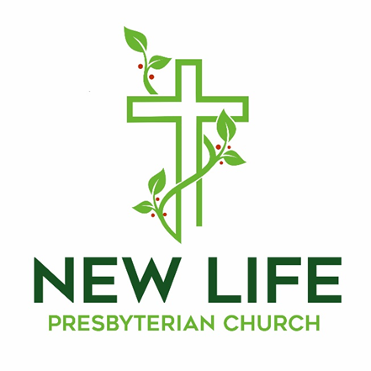

**Embrace God’s Beauty; Extend God’s Love**

**Welcome to New Life Presbyterian Church**

Dear Visitor,

Welcome! It is a joy and privilege to gather this morning to worship God together. Here at New Life, we are a small part of the worldwide, multi-ethnic, multi-generational, multi-cultural body of Christ. Although we are Presbyterian and Reformed, our identity is found not in what makes us distinct, but in what makes us united: we belong to the Lord Jesus Christ. He is not only our Maker; He is our Savior. If you have put your hope and trust in Him, we welcome you as a brother or sister. It is in Him that we have New Life!

If you are here this morning and do not know what you think about Jesus, or about the claims of the Bible, we are delighted that you have chosen to join us for the morning. We hope and trust that you will experience a warm welcome, regardless of your religious convictions. We are a community of those who have experienced the embrace of God, through Jesus Christ. It is our goal to show that love to all who are around us. Please know that I personally would welcome your thoughts and perspectives on anything you observe this morning.

May the grace and peace of Christ be with you all!

Joyfully,



Pastor Erik Swanson

P.S. Due to COVID 19 concerns, for the time being there is no nursery. When it is wise and practical, we will resume our nursery. Parents are encouraged to bring their children to worship. Even as children and parents may need to use the backspace of the sanctuary to move around, the church rejoices in the blessing that families are!

**Worshiping God**

May 24, 2020

**Reflections:**

*"Our prayers may be awkward. Our attempts may be feeble. But since the power of prayer is in the one who hears it and not in the one who says it, our prayers do make a difference."* - Max Lucado

*"To be a Christian without prayer is no more possible than to be alive without breathing."* - Martin Luther

**Prelude**

**Welcome and Announcements**

**Call to Worship –** *Isaiah 30:15,18 Erik Swanson*

*Minister: For thus said the Lord God, the Holy One of Israel:*

***People: “In returning and rest you shall be saved; in quietness and in trust shall be***

***your strength.”***

*Minister: Therefore the Lord waits to be gracious to you, and therefore he exalts*

*himself to show mercy to you.*

***People: For the Lord is a God of justice; blessed are all those who wait for him.***

**Prayer of Praise**

**Holy, Holy, Holy**

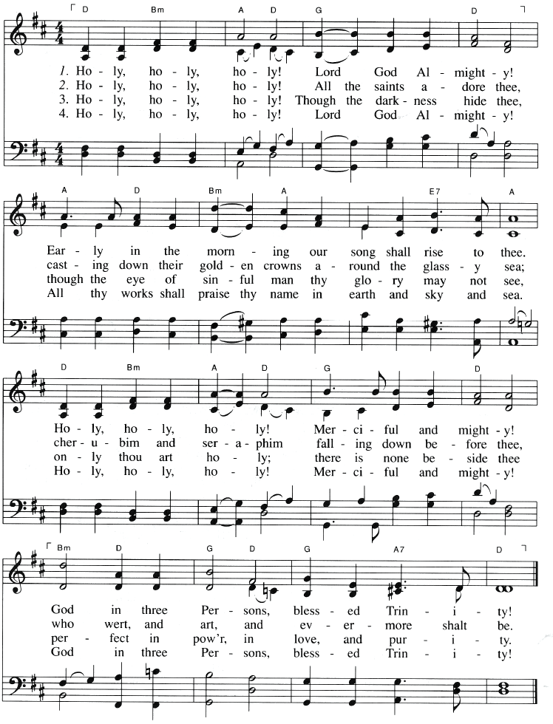

**Confession of Faith –** *The**Apostle’s Creed:*

**I believe in God, the Father Almighty, Creator of Heaven and earth; and in Jesus Christ, His only Son Our Lord, who was conceived by the Holy Spirit, born of the Virgin Mary, suffered under Pontius Pilate, was crucified, died, and was buried. He descended into Hell; the third day He rose again from the dead; He ascended into Heaven, and sitteth at the right hand of God, the Father almighty; from thence He shall come to judge the living and the dead. I believe in the Holy Spirit, the holy Catholic Church, the communion of saints, the forgiveness of sins, the resurrection of the body and life everlasting. Amen.**

**NT Scripture Reading:** *Matthew 6:5-18 Patrick Vaughn*

*Reader: This is the word of the Lord.*

**All: Thanks be to God!**

**Prayer of Confession:**

**Pardon our sins, merciful Lord. We have been hasty and short in prayer, and this first sin of the day leads to so many others. Keep us from robbing you of the true worship which your glory requires and which our hearts so urgently need. Wipe out our sins, known and unknown, felt and unfelt, remembered and forgotten. Enable us to remember the blood that cleanses from all sin, and the grace which overwhelms all evil, in Jesus’ name. Amen.**

**Assurance of Grace –** *Zephaniah 3:16b-17*

*Leader:*  16b“Fear not, O Zion; let not your hands grow weak. 17The LORD your God is in your midst, a mighty one who will save; he will rejoice over you with gladness; he will quiet you by his love; he will exult over you with loud singing.

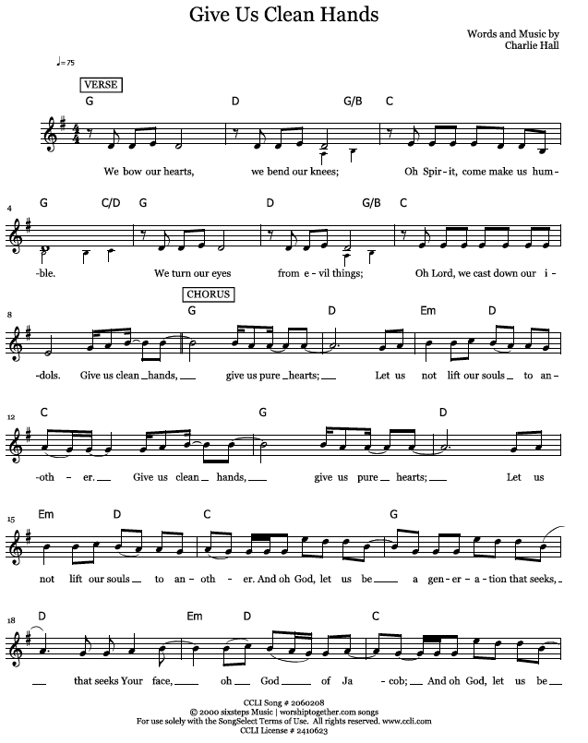

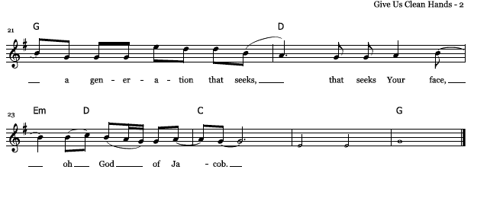

**Prayers of the People**

**Ministry Moment**

**Offering Our Gifts**

The offering allows friends and members of our church to express their faith in God’s Word, and to support the extension of that Word in our community and world.

**Doxology** Praise God from whom all blessings flow!

Praise Him, all creatures here below!

Praise Him above, ye heavenly host!

Praise, Father, Son, and Holy Ghost!

Amen.

**Scripture Reading -** *Psalm 119:169-176*

[169](http://biblehub.com/psalms/119-169.htm)Let my cry come before you, O LORD; give me understanding according to your word! [170](http://biblehub.com/psalms/119-170.htm)Let my plea come before you; deliver me according to your word. [171](http://biblehub.com/psalms/119-171.htm)My lips will pour forth praise, for you teach me your statutes. [172](http://biblehub.com/psalms/119-172.htm)My tongue will sing of your word, for all your commandments are right. [173](http://biblehub.com/psalms/119-173.htm)Let your hand be ready to help me, for I have chosen your precepts. [174](http://biblehub.com/psalms/119-174.htm)I long for your salvation, O LORD, and your law is my delight. [175](http://biblehub.com/psalms/119-175.htm)Let my soul live and praise you, and let your rules help me. [176](http://biblehub.com/psalms/119-176.htm)I have gone astray like a lost sheep; seek your servant, for I do not forget your commandments.

**Sermon: Desiring God Through Prayer** *Rev. Erik Swanson*

**Series: Desiring God**

**Sermon Notes**

### 

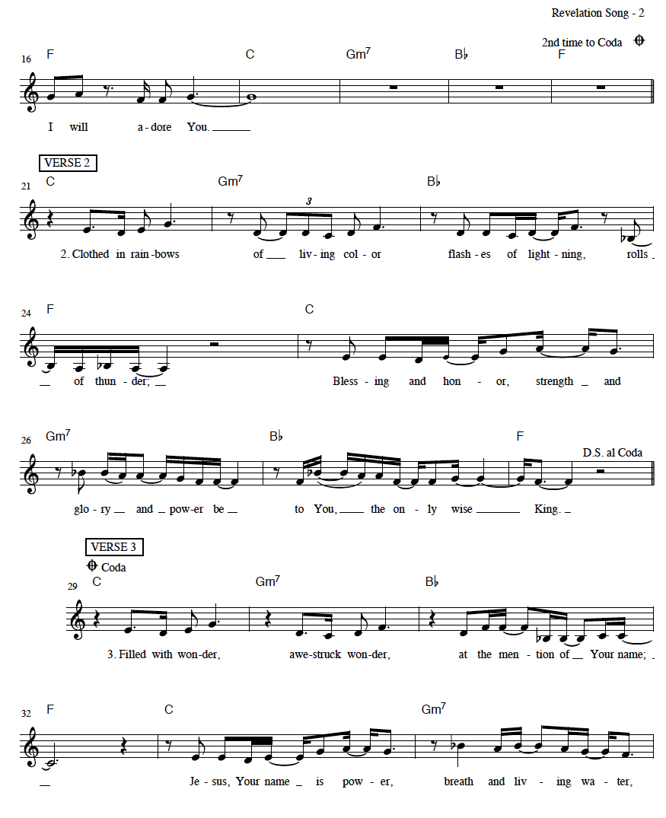

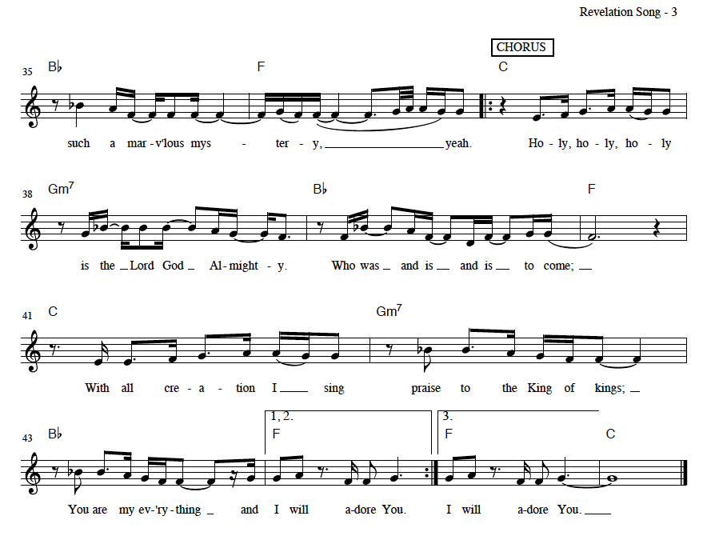

**Benediction –** *1 Thessalonians 5:23-24*

*Leader:* [23](http://biblehub.com/1_thessalonians/5-23.htm)Now may the God of peace himself sanctify you completely, and may your whole spirit and soul and body be kept blameless at the coming of our Lord Jesus Christ. [24](http://biblehub.com/1_thessalonians/5-24.htm)He who calls you is faithful; he will surely do it.

**The Sending**

*Leader: Go in peace to love and serve the Lord.*

**All: Thanks be to God!**

**Postlude**

---------------------------------------------------------------------------------------------------------------------

*All songs are either public domain or licensed under CCLI #2410623.

**This Week at New Life**

|  |  |  |  |
| --- | --- | --- | --- |
| **Date** | **Time** | **Event** | **Location** |
| Sun, 5/24 | 10:00 AM | Corporate Worship | Sanctuary |
| Sun, 5/24 | 7:00 PM | Adult Sunday School/Christian Ed Class | Homes via Zoom |
| Tue, 5/26 | 9:30 AM | Women’s Bible Study | Homes via Zoom |
| Wed, 5/27 | 7:00 PM | Women’s Bible Study | Homes via Zoom |
| Thur, 5/28 | 8:00 PM | College and Career Ages Meeting | Homes via Zoom |
| Sun, 5/31 | 10:00 AM | Corporate Worship | Sanctuary |
| Sun, 5/31 | 7:00 PM | Adult Sunday School/Christian Ed Class | Homes via Zoom |

**Church Financial Summary**

|  |  |  |
| --- | --- | --- |
| **Category** | **Budget** | **Actual** |
| **Year to Date Income** | $80,000.00 | $73,989.53 |
| **Last Week** | $4,000.00 | $5,970.00 |

**Announcements**

* ***Deacon Candidate and Congregational Meeting:*** The session is pleased to announce those deacon candidates eligible for a congregational vote. The candidates are Leon Leader, Blaine Marsh, and Iren Snavely. The session is calling for a congregational meeting at 11:45 AM on Sunday, June 28th. The purpose of this meeting is for the congregation to vote in regards to the above deacon candidates. Should any of you have questions about the process, a copy of the relevant portion of our Book of Church Order (Chapter 24) is available in the information center. Please continue to pray for God’s guidance in this process.
* ***Offering for the Diaconate:*** On June 7th, an additional special offering will be taken for the deacon’s fund. Contact the church office for a copy of the letter which was distributed regarding that offering.
* ***Missions Team Member Needed:*** The Missions Team is looking for one more congregant who will assist them in the work of the committee. The team selects missionaries for NLPC support, and the team prays regularly for the missionaries and seeks to encourage congregational support of missions. See Marlene Spark for more details.
* ***Worship Service Options:*** All are invited to attend in person at New Life. The service will be live streamed via YouTube on the church website home page. Click the livestream button. PDF’s of the bulletin will be available for download. They may be found under the sermons tab. Click on the title that lists that service date, and the bulletin is there as a download. The complete service will be available on the church website, under the sermons tab, as well as on the church Facebook page. A CD will be burned and distributed to those who request it.
* ***Worship Service CD Creation and Distribution Needed:*** A volunteer is needed to burn the CD of the service. The goal is to do this as soon as the sermon is uploaded, so that these CD’s can be dropped off on the drive home from church. Volunteers are needed to drop off CD’s of the service. Please contact Pastor Erik if you are willing to help.

**Ongoing Groups for Fellowship and Growth**

* ***Christian Education:*** Adult Sunday School Class, Sunday Evenings at 7:00 PM via Zoom. <https://us02web.zoom.us/j/131066007?pwd=MElmb3dOV3NrN2x1QVQzK0Z4VFYvUT09>

Phone: (301) 715 8592 Meeting ID: 131 066 007 Password: 383366

* ***Wednesday Morning Bible Study:*** Postponed
* ***Thursday Morning “Mom’s Group” Bible Study:*** Contact Joy Swanson for more information.
* ***Men’s Group:*** Contact Rob Rothermel for information.
* ***Women’s Bible Study:*** Contact Marlene Spark for more information.
* ***Youth Group:*** Please contact the church office for more information.
* ***Second Sunday Lunch***: Postponed
* ***Prayer Small Group:*** Contact Sue Rothermel for more details.
* ***Bible Study Fellowship (BSF):*** Postponed

**New Life Presbyterian Church Vision, Mission, and Core Values**

**Vision: *To see York and beyond embrace God’s beauty and extend God’s love.***

**Mission: *To receive the grace of God, to give the glory to God,***

***and to follow the Word of God.***

**Core Values:**

* **His Voice**: While God speaks through creation, God speaks directly in the

Word of God. Therefore, we receive and obey God’s Word.

* **His Plan:** Because God is love, God is on a mission to save. We seek to

follow Him in His mission.

* **His Grace:** The good news for sinners is that Jesus saves, by grace. Through

faith we believe in Christ and grow in Christ.

* **His Power:** Only God has power to save and sustain His people. We depend

on the Holy Spirit.

* **His People:** In Christ, the church is made one. In the midst of both unity and

diversity, we must love one another.

* **His Gifts:** Creation, redemption, and the ability to serve are all gifts from

God. The entire church should be equiped and empowered to

serve gratefully.

* **His Timing:** All things are in God’s hands. Therefore, we trust in His ways.

For more information, please visit: http://www.newlifeyorkpca.com/about-us.html

**New Life Presbyterian Church, (717) 855-2360**

**970 Cape Horn Rd., York, PA 17402**

**admin@newlifeyorkpca.com**