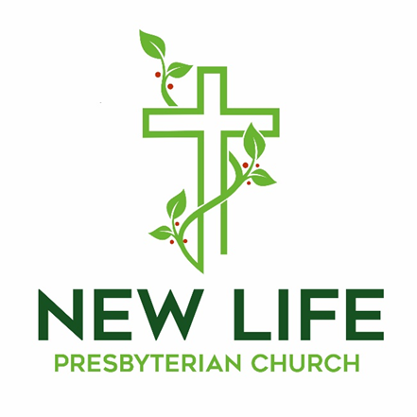

**Embrace God’s Beauty; Extend God’s Love**

**Welcome to New Life Presbyterian Church**

Dear Visitor,

Welcome! It is a joy and privilege to gather this morning to worship God together. Here at New Life, we are a small part of the worldwide, multi-ethnic, multi-generational, multi-cultural body of Christ. Although we are Presbyterian and Reformed, our identity is found not in what makes us distinct, but in what makes us united: we belong to the Lord Jesus Christ. He is not only our Maker; He is our Savior. If you have put your hope and trust in Him, we welcome you as a brother or sister. It is in Him that we have New Life!

If you are here this morning and do not know what you think about Jesus, or about the claims of the Bible, we are delighted that you have chosen to join us for the morning. We hope and trust that you will experience a warm welcome, regardless of your religious convictions. We are a community of those who have experienced the embrace of God, through Jesus Christ. It is our goal to show that love to all who are around us. Please know that I personally would welcome your thoughts and perspectives on anything you observe this morning.

May the grace and peace of Christ be with you all!

Joyfully,



Pastor Erik Swanson

P.S. Due to COVID 19 concerns, for the time being there is no nursery. When it is wise and practical, we will resume our nursery. Parents are encouraged to bring their children to worship. Even as children and parents may need to use the backspace of the sanctuary to move around, the church rejoices in the blessing that families are!

**Worshiping God**

May 17, 2020

**Reflections:**

*“I take this [Psalm 19] to be the greatest poem in the Psalter and one of the greatest lyrics in the world” –* C.S. Lewis

*“The law of the LORD is perfect, reviving the soul.” -* David

**Prelude**

**Welcome and Announcements**

**Call to Worship –** *Psalm 100 Erik Swanson*

*Minister: Shout for joy to the Lord, all the earth.*

***People: Worship the Lord with gladness; come before him with joyful songs.***

*Minister: Know that the Lord is God. It is he who made us, and we are is; we are his*

*people, the sheep of his pasture.*

***People: Enter his gates with thanksgiving and his courts with praise; give thanks to***

***him and praise his name.***

***All: For the Lord is good and his love endures forever; his faithfulness continues***

***through all generations.***

**Prayer of Praise**

**Come People of the Risen King**

### 

### 

***Verse 1***

Come people of the Risen King,

Who delight to bring Him praise.

Come all and tune your hearts to sing,

To the Morning Star of grace.

From the shifting shadows of the earth,

We will lift our eyes to Him.

Where steady arms of mercy reach,

To gather children in.

***Chorus***

Rejoice, rejoice let ev'ry tongue rejoice.

One heart, one voice,

O Church of Christ rejoice.

***Verse 2***

Come those whose joy is morning sun,

And those weeping through the night.

Come those who tell of battles won,

And those struggling in the fight.

For His perfect love will never change,

And His mercies never cease.

But follow us through all our days,

With the certain hope of peace.

***Verse 3***

Come young and old from ev'ry land,

Men and women of the faith.

Come those with full or empty hands,

Find the riches of His grace.

Over all the world His people sing,

Shore to shore we hear them call.

The truth that cries through ev'ry age,

Our God is all in all.

**Confession of Faith –** *The**Apostle’s Creed:*

**I believe in God, the Father Almighty, Creator of Heaven and earth; and in Jesus Christ, His only Son Our Lord, who was conceived by the Holy Spirit, born of the Virgin Mary, suffered under Pontius Pilate, was crucified, died, and was buried. He descended into Hell; the third day He rose again from the dead; He ascended into Heaven, and sitteth at the right hand of God, the Father almighty; from thence He shall come to judge the living and the dead. I believe in the Holy Spirit, the holy Catholic Church, the communion of saints, the forgiveness of sins, the resurrection of the body and life everlasting. Amen.**

**NT Scripture Reading:** *2 Timothy 3:14-17 Connie Kay*

*Reader: This is the word of the Lord.*

**All: Thanks be to God!**

**Prayer of Confession:**

**Our Father,**

**You have not left us alone. As your Son promised, you have given us your Spirit. We are in need of daily guidance. Yet, we confess that we often fail to listen to you. We have a tendency to grieve the Spirit by going our own way. Rather than wait upon you and listen to your word, we often go off on our own. We repent of this sin, and we ask that you would guide us. Please direct our path. Lead us. We submit our lives to you, for we come in Jesus’ name, Amen!**

**Assurance of Grace –** *Zephaniah 3:16b-17*

*Leader:*  16b“Fear not, O Zion; let not your hands grow weak. 17The LORD your God is in your midst, a mighty one who will save; he will rejoice over you with gladness; he will quiet you by his love; he will exult over you with loud singing.

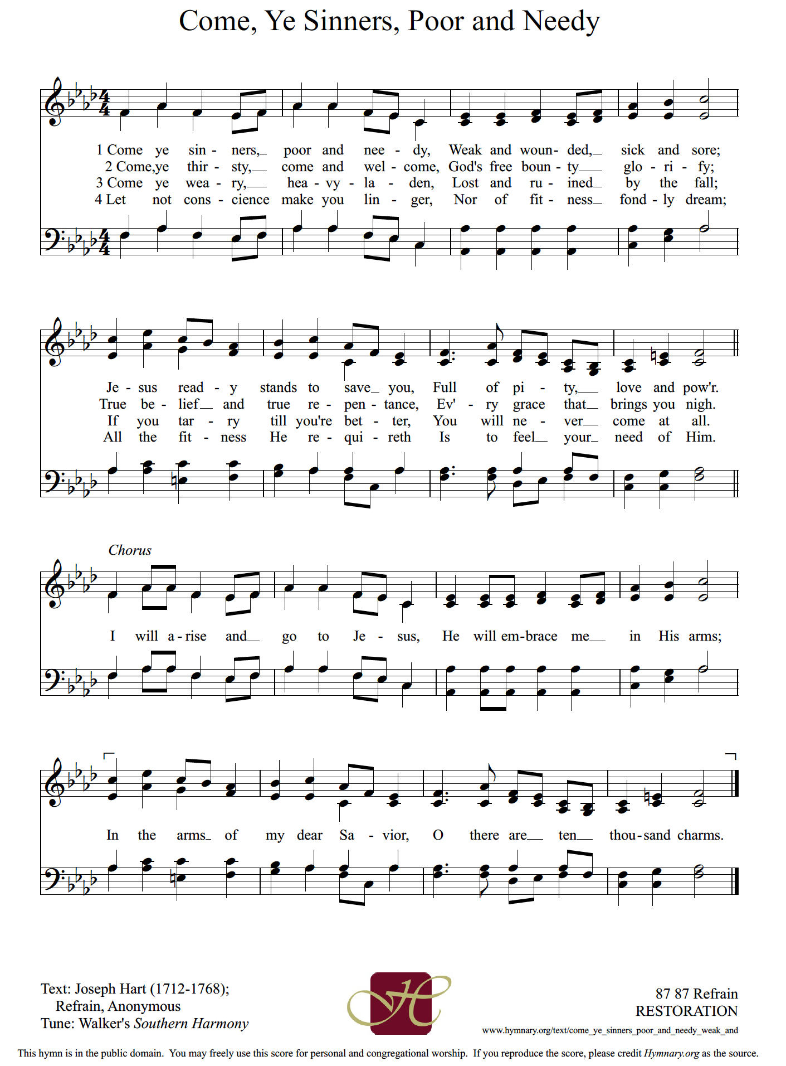

**Prayers of the People**

**Ministry Moment**

**Offering Our Gifts**

The offering allows friends and members of our church to express their faith in God’s Word, and to support the extension of that Word in our community and world.

**Doxology** Praise God from whom all blessings flow!

Praise Him, all creatures here below!

Praise Him above, ye heavenly host!

Praise, Father, Son, and Holy Ghost!

Amen.

**Scripture Reading -** *Psalm 19:7-14*

[**7**](http://biblehub.com/psalms/19-7.htm)The law of the LORD is perfect,reviving the soul; the testimony of the LORD is sure, making wise the simple; [**8**](http://biblehub.com/psalms/19-8.htm)the precepts of the LORD are right, rejoicing the heart; the commandment of the LORD is pure, enlightening the eyes; [**9**](http://biblehub.com/psalms/19-9.htm)the fear of the LORD is clean, enduring forever; the rules of the LORD are true, and righteous altogether. [**10**](http://biblehub.com/psalms/19-10.htm)More to be desired are they than gold, even much fine gold; sweeter also than honey and drippings of the honeycomb. [**11**](http://biblehub.com/psalms/19-11.htm)Moreover, by them is your servant warned; in keeping them there is great reward. [**12**](http://biblehub.com/psalms/19-12.htm)Who can discern his errors? Declare me innocent from hidden faults. [**13**](http://biblehub.com/psalms/19-13.htm)Keep back your servant also from presumptuous sins; let them not have dominion over me! Then I shall be blameless, and innocent of great transgression. [**14**](http://biblehub.com/psalms/19-14.htm)Let the words of my mouth and the meditation of my heart be acceptable in your sight, O LORD, my rock and my redeemer.

**Sermon: Desiring the Perfect Word** *Rev. Erik Swanson*

**Series: Desiring God**

**Sermon Notes**

## 

## **Psalm 19**

***Verse***

May the words of my mouth,

And the meditations of my heart,

Be pleasing to You, pleasing to You.

May the words of my mouth,

And the meditations of my heart,

Be pleasing to You, my God.

***Chorus***

You're my Rock and my Redeemer.

You're the reason that I sing.

I desire to be a blessing in Your eyes,

Ev'ry hour, ev'ry moment.

Lord I want to be Your servant.

I desire to be a blessing,

In Your eyes, in Your eyes.

***Ending***

May the words of my mouth,

And the meditations of my heart,

Be pleasing to You, my God.

### 

**Benediction –** *1 Thessalonians 5:23-24*

*Leader:* [23](http://biblehub.com/1_thessalonians/5-23.htm)Now may the God of peace himself sanctify you completely, and may your whole spirit and soul and body be kept blameless at the coming of our Lord Jesus Christ. [24](http://biblehub.com/1_thessalonians/5-24.htm)He who calls you is faithful; he will surely do it.

**The Sending**

*Leader: Go in peace to love and serve the Lord.*

**All: Thanks be to God!**

**Postlude**

---------------------------------------------------------------------------------------------------------------------

*All songs are either public domain or licensed under CCLI #2410623.

**This Week at New Life**

|  |  |  |  |
| --- | --- | --- | --- |
| **Date** | **Time** | **Event** | **Location** |
| Sun, 5/17 | 10:00 AM | Corporate Worship | Sanctuary |
| Sun, 5/17 | 6:00 PM | Church-wide Fellowship | Homes via Zoom |
| Sun, 5/17 | 7:00 PM | Adult Sunday School/Christian Ed Class | Homes via Zoom |
| Tue, 5/19 | 9:30 AM | Women’s Bible Study | Homes via Zoom |
| Tue, 5/19 | 7:00 PM | Evening Prayer | Homes via Zoom |
| Wed, 5/20 | 7:00 PM | Women’s Bible Study | Homes via Zoom |
| Thur, 5/21 | 8:00 PM | College and Career Ages Meeting | Homes via Zoom |
| Fri, 5/22 | 4:30 PM | Church-wide Devotional | Homes via Zoom |
| Sun, 5/24 | 10:00 AM | Corporate Worship | Sanctuary |
| Sun, 5/24 | 7:00 PM | Adult Sunday School/Christian Ed Class | Homes via Zoom |

**Church Financial Summary**

|  |  |  |
| --- | --- | --- |
| **Category** | **Budget** | **Actual** |
| **Year to Date Income** | $76,000.00 | $68,019.53 |
| **Last Week** | $4,000.00 | $4,390.00 |

**Announcements**

* ***Church-Wide Fellowship:*** 6:00 PM this evening via Zoom. <https://us02web.zoom.us/j/84635376900?pwd=c25vWDI5UVlFcCtHTy9hSnBKeWkyZz09> Phone: 301 715 8592 Meeting ID: 846 3537 6900 Password: 278603

* ***Missions Team Member Needed:*** The Missions Team is looking for one more congregant who will assist them in the work of the committee. The team selects missionaries for NLPC support, and the team prays regularly for the missionaries and seeks to encourage congregational support of missions. See Marlene Spark for more details.

* ***Pastoral Visits:*** I am available for pastoral visits, whether over the phone, wearing masks at church, visiting through the glass of your front door, or through some other context. Please call 717 501-6082 to schedule a visit.

* ***Serving Others:*** How can you serve others during Covid-19? Some service opportunities can happen from your own home! One practical list of ways to serve may be found here:[https://www.pennlive.com/coronavirus/2020/03/how-to-volunteer-donate-in-central-pa-during-coronavirus-pandemic.html](https://newlifeyork.us6.list-manage.com/track/click?u=41ff70cd8a599701b601674f5&id=829b0fabf5&e=5b4fcf8514). A summary of volunteer needs includes:

- Working with a community organization to host a blood drive

- Donating diapers

- Helping pack Crisis Response Boxes

- Taking phone calls at home for a helpline

- Distributing Family Food Boxes

- Packing and carrying food for home deliveries

**Ongoing Groups for Fellowship and Growth**

* ***Christian Education:*** Adult Sunday School Class, Sunday Evenings at 7:00 PM via Zoom. <https://us02web.zoom.us/j/131066007?pwd=MElmb3dOV3NrN2x1QVQzK0Z4VFYvUT09>

Phone: (301) 715 8592 Meeting ID: 131 066 007 Password: 383366

* ***Wednesday Morning Bible Study:*** Postponed
* ***Thursday Morning “Mom’s Group” Bible Study:*** Contact Joy Swanson for more information.
* ***Men’s Group:*** Contact Rob Rothermel for information.
* ***Women’s Bible Study:*** Contact Marlene Spark for more information.
* ***Youth Group:*** Please contact the church office for more information.
* ***Second Sunday Lunch***: Postponed
* ***Prayer Small Group:*** Contact Sue Rothermel for more details.
* ***Bible Study Fellowship (BSF):*** Postponed

**New Life Presbyterian Church Vision, Mission, and Core Values**

**Vision: *To see York and beyond embrace God’s beauty and extend God’s love.***

**Mission: *To receive the grace of God, to give the glory to God,***

***and to follow the Word of God.***

**Core Values:**

* **His Voice**: While God speaks through creation, God speaks directly in the

Word of God. Therefore, we receive and obey God’s Word.

* **His Plan:** Because God is love, God is on a mission to save. We seek to

follow Him in His mission.

* **His Grace:** The good news for sinners is that Jesus saves, by grace. Through

faith we believe in Christ and grow in Christ.

* **His Power:** Only God has power to save and sustain His people. We depend

on the Holy Spirit.

* **His People:** In Christ, the church is made one. In the midst of both unity and

diversity, we must love one another.

* **His Gifts:** Creation, redemption, and the ability to serve are all gifts from

God. The entire church should be equiped and empowered to

serve gratefully.

* **His Timing:** All things are in God’s hands. Therefore, we trust in His ways.

For more information, please visit: http://www.newlifeyorkpca.com/about-us.html

**New Life Presbyterian Church, (717) 855-2360**

**970 Cape Horn Rd., York, PA 17402**

**admin@newlifeyorkpca.com**