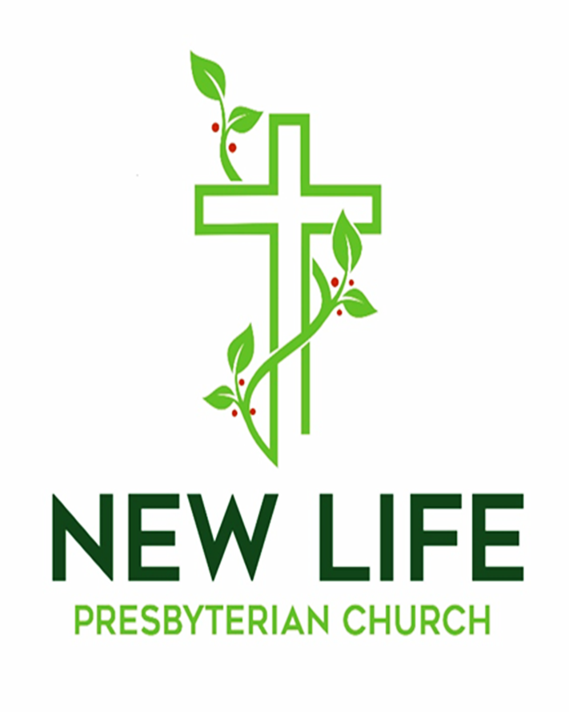

Embrace God’s Beauty; Extend God’s Love

February 8, 2026

Welcome to New Life Presbyterian Church

Dear Visitor,

Welcome! It is a joy and privilege to gather this morning to worship God together. Here at New Life, we are a small part of the worldwide, multi-ethnic, multi-generational, multi-cultural body of Christ. Although we are Presbyterian and Reformed, our identity is found not in what makes us distinct, but in what makes us united: we belong to the Lord Jesus Christ. He is not only our Maker; He is our Savior. If you have put your hope and trust in Him, we welcome you as a brother or sister. It is in Him that we have New Life!

If you are here this morning and do not know what you think about Jesus, or about the claims of the Bible, we are delighted that you have chosen to join us for the morning. We hope and trust that you will experience a warm welcome, regardless of your religious convictions. We are a community of those who have experienced the embrace of God, through Jesus Christ. It is our goal to show that love to all who are around us. Please know that I personally would welcome your thoughts and perspectives on anything you observe this morning.

May the grace and peace of Christ be with you all!

Joyfully,

Pastor Erik Swanson

P.S. Jesus welcomed children in worship, and so do we! Having said that, here are some additional options for parents:
- There is a staffed nursery, off the fellowship hall, for children ages 0-4.
- A private “nursing moms” alcove is available in the nursery.
- Classroom 1 is a “Wiggle Room” for parents who desire a place to be with their children who need to wiggle while still being able to watch the livestream.

Please be aware that we livestream our services.
Worshiping God
February 8, 2026

Reflections

My mama always said... - Forrest Gump

If the lifestyle does not match the profession, the latter is to be discounted.
- Peter Davids

The fear of the Lord is the beginning of wisdom - Proverbs 9:10

Welcome and Announcements Pastor Erik Swanson
Prelude

Call to Worship – Psalm 98:1-4 Elder Will Pope

Leader: Oh sing to the LORD a new song, for he has done marvelous things!
His right hand and his holy arm have worked salvation for him.

All: The LORD has made known his salvation;
he has revealed his righteousness in the sight of the nations.

Leader: He has remembered his steadfast love and faithfulness to the house

of Israel.
All the ends of the earth have seen the salvation of our God.

All: Make a joyful noise to the LORD, all the earth;

break forth into joyous song and sing praises!

Prayer of Praise

Build My Life

Verse 1

Worthy of ev'ry song we could ever sing

Worthy of all the praise we could

ever bring

Worthy of ev'ry breath we could

ever breathe

We live for You

Verse 2

Jesus the name above ev'ry other name

Jesus the only one who could ever save

Worthy of ev'ry breath we could

ever breathe

We live for You

We live for You

Chorus

Holy there is no one like You

There is none beside You

Open up my eyes in wonder and show me who You are

And fill me with Your heart

And lead me in Your love to those

around me

Bridge

I will build my life upon Your love

It is a firm foundation

I will put my trust in You alone

And I will not be shaken (REPEAT)

Chorus

Holy there is no one like You

There is none beside You

Open up my eyes in wonder and show me who You are

And fill me with Your heart

And lead me in Your love to those

around me

Tag

Jesus the name above ev'ry other name

Jesus the only one who could ever save

“Build My Life” words and music by Brett Younker, Karl Martin, Kirby Kaple, Matt Redman, Pat Barrett

© 2016 Kaple Music, Capitol CMG Genesis, Housefires Sounds, Said and Done Music, sixsteps Music, Thankyou Music, Vamos Publishing, worshiptogether.com songs, Martin, Karl Andrew, Bethel Music Publishing

Used by Permission. CCLI License #2410623

How Firm a Foundation

Affirmation of Faith – Romans 8:38-39

³⁸ For I am sure that neither death nor life, nor angels nor rulers, nor things present nor things to come, nor powers, ³⁹ nor height nor depth, nor anything else in all creation, will be able to separate us from the love of God in Christ Jesus our Lord.

Scripture Reading – Proverbs 2:1-6 Connie Kay

Minister: This is the word of the LORD.
All: Thanks be to God!

Prayer of Confession

Our Father, You have not left us alone. As your Son promised, you have given us your Spirit. We are in need of daily guidance. Yet, we confess that we often fail to listen to you. We have a tendency to grieve the Spirit by going our own way. Rather than wait upon you and listen to your word, we often go off on our own. We repent of this sin, and we ask that you would guide us. Please direct our path. Lead us. We submit our lives to you, for we come in Jesus’ name, Amen!

Assurance of Forgiveness – 1 John 2:1-2

My little children, I am writing these things to you so that you may not sin. But if anyone does sin, we have an advocate with the Father, Jesus Christ the righteous.
He is the propitiation for our sins, and not for ours only but also for the sins of the
whole world.

Breathe on Me, Breath of God

Prayers of the People

Ministry Moment

Offering
The offering allows friends and members of our church to express their faith in God’s Word, and to support the extension of that Word in our community and in the world.

Doxology:
Praise God from whom all blessings flow
Praise Him all creatures here below
Praise Him above ye heavenly host
Praise Father Son and Holy Ghost
Amen

Scripture – James 3:13-18

Who is wise and understanding among you? By his good conduct let him show his works in the meekness of wisdom. ¹⁴ But if you have bitter jealousy and selfish ambition in your hearts, do not boast and be false to the truth. ¹⁵ This is not the wisdom that comes down from above, but is earthly, unspiritual, demonic. ¹⁶ For where jealousy and selfish ambition exist, there will be disorder and every vile practice. ¹⁷ But the wisdom from above is first pure, then peaceable, gentle, open to reason, full of mercy and good fruits, impartial and sincere. ¹⁸ And a harvest of righteousness is sown in peace by those who make peace.

Sermon: Wisdom from Above Pastor Erik Swanson

Sermon Notes

Celebration of the LORD’s Supper
New Life Church invites all baptized Christians who are members of Christ’s church to join us in this feast of bread and wine. The inner circle of cups contains red wine and the outer circle of cups contains white grape juice. If you are unable to consume wheat, gluten-free crackers are available.

Prayer

Words of Institution – from 1 Corinthians 11

Minister: Let us proclaim the mystery of the faith.
All: Christ has died.
Christ is risen.
Christ will come again.

Communing Together
The elders and deacons will serve you in your seats. Please hold the elements so that we can partake together after all have been served. Use the extra time during communion for prayer and reflection.

Prayer of Thanksgiving

Hear the Call of the Kingdom

Verse 1

Hear the call of the kingdom

Lift your eyes to the King

Let His song rise within you

As a fragrant offering

Of how God rich in mercy came in Christ to redeem

All who trust in His unfailing grace

Verse 2

Hear the call of the kingdom

To be children of light

With the mercy of heaven the humility

of Christ

Walking justly before Him

Loving all that is right

That the life of Christ may shine

through us

Chorus

King of heaven we will answer the call

We will follow bringing hope to the world

Filled with passion filled with power

to proclaim

Salvation in Jesus' name

Verse 3

Hear the call of the kingdom

To reach out to the lost

With the Father's compassion

In the wonder of the cross

Bringing peace and forgiveness

And a hope yet to come

Let the nations put their trust in Him

Chorus

King of heaven we will answer the call

We will follow bringing hope to the world

Filled with passion filled with power

to proclaim

Salvation in Jesus' name

(REPEAT)

“Hear The Call Of The Kingdom” words and music by Keith Getty, Kristyn Getty, Stuart Townend

© 2006 Thankyou Music

Used by Permission. CCLI License #2410623

Benediction – Philippians 4:7

And the peace of God, which surpasses all understanding, will guard your hearts and your minds in Christ Jesus.

The Sending

Minister: Go in peace, to love and serve the LORD.
All: Thanks be to God!

Postlude

** Would you like to pray with someone today about a need? Following the service a PRAYER TEAM member is available to pray with you. Find them up front to the right of
the platform.**

This Week at New Life

Date | Time | Event | Location
Sun. 2/8 | 9:00 am | Sunday School for All Ages | Classrooms
Sun. 2/8 | 10:00 am | Corporate Worship | Sanctuary
Sun. 2/8 | 11:30 am | Souper Bowl Lunch | Fellowship area
W. 2/11 | 9:00 am | Moms + | Classroom 2
W. 2/11 | 9:00 am | Wednesday Morning Bible Study | Classroom 1
W. 2/11 | 7:00 pm | Prayer Meeting | Classroom 3
W. 2/11 | 7:00 pm | Music Team Rehearsal | Sanctuary
Sun. 2/15 | 9:00 am | Sunday School for All Ages | Classrooms
Sun. 2/15 | 10:00 am | Corporate Worship | Sanctuary
Sun. 2/15 | 6:00 pm | Community Groups | Members’ Homes

Church Financial Summary

Category | Budget | Actual
Year to Date 2026 | $43,750.00 | $41,309.10
Week of 2/1/26 | $8,750.00 | $11,232.00

Announcements

- Lancaster YMCA Homeless Shelter: Connie Kay is collecting new (or very gently used) hats, gloves, socks, and scarves for the YMCA homeless shelter in Lancaster. This shelter houses up to 80 men and 20 women each night and is in critical need of these winter items. Donations may be given to Connie and are due today.
- New Life is excited to host Presbytery on Sat. Feb. 21! We will be serving breakfast and lunch to those attending and would love your help. Please see sign-up sheets in the foyer. If you have any questions, please see Shyrl (breakfast) or Connie (lunch).
- Women’s Bible Study: Our spring study of the book of James starts March 10. Please join us for in-depth study, sharing insights, lively discussion, and opportunities to share how to apply God’s wisdom. We will be using the guide by Lydia Brownback, James: Walking in Wisdom. All women of the church are invited, and your friends! When: Tuesdays March 10 through May 12, mornings 9:30-11am at the church, or evenings 7-8:15pm on Zoom. For more information or to sign up, please contact Marlene Spark or the office. If we have more than 10 ladies, we will pre-order the book at a reduced price so please sign up by Sun. Feb. 22. The price will be no more than $9. Scholarships are available if price is a concern.
- Baby Bottle Campaign: Thank you to all who are participating in Human Life Service’s baby bottle campaign. Please note deadline for returning them is Sun. March 1.
- Mark Your Calendars Now: On Sat. March 7 from 3-5pm, New Life will be going to the York County Astronomical Society Planetarium (located in the York Learning Center, 301 East 6th Ave, York). We will view two filmed shows (Cosmic Castaways and Chasing the Ghost Particle) and have a live presentation of what can be seen in the March night skies. This event is for ages 12 years old and upwards. We will have 60 seats available so a signup sheet will be put out in February. For more information contact Mark Deckard or the office.
- New Adult Sunday School Class: Starting Sun. March 8 there will be a Sunday school class in classroom 2 called: “We Become What We Worship: A Biblical Theology of Idolatry.”
- Winter Women’s Book Club Potluck: Join us on Sun. March 8 at 5:30pm for a potluck and discussion of Ken Isaacs’ book Running to the Fire: Helping in Jesus’ Name. We will meet at the home of Connie Kay. Please RSVP to Connie.

Groups for Fellowship and Growth

Christian Education: Youth and Children’s classes: Pre-K through 1st meets in classroom 5, 2nd-4th meets in classroom 4, 5-8th meets in classroom 3, and 9-12th meets in classroom 1.

Two adult classes: one studying Ezra and Nehemiah and meeting in the Aquarium room and the other studying A Praying Church and meeting in Classroom 2.

Women’s Bible Study: All women of the church and their friends are welcome to attend a 10-week study, James: Walking in Wisdom, by Lydia Brownback, beginning Tues. March 10. Group meetings occur in the church Aquarium Room on Tuesdays 9:30–11am, or on Zoom in the evenings from 7– 8:15pm. Please contact Marlene Spark for details.

Wednesday Morning Bible Study: Interested in discussing the upcoming sermon text? Join us at New Life in Classroom 1 at 9am.

Moms+: Women, please join us at the church on Wednesday mornings from 9-11am. Childcare and Bible classes for your kids are also provided.

Men’s Breakfast is in transition. Stay tuned for details.

Youth Group: Please contact the church office for information.

Prayer Small Group: NLPC has two ongoing opportunities dedicated to prayer. In the midday, prayer meets on the 1st and 3rd Tuesdays from 11am-12pm in classroom 1. In the evenings, prayer meets on the 2nd and 4th Wednesdays from 7-8pm in the classroom 3. Sherry Rishel is the point of contact.

Bible Study Fellowship (BSF): Contact Elder Will Pope with questions.

Discipleship Groups: Same-gender groups meet to encourage each other to follow Jesus as we walk with each other. Please contact Pastor Erik to join a group.

Community Groups: Designed to be a microcosm of the church, this is an intergenerational home-gathering for fellowship, food, Bible study, (singing), and prayer. We meet on the 1st and 3rd Sundays of the month from 6-7:30pm. See Pastor Erik if you would like to join

a group.

New Life Presbyterian Church Vision, Mission, and Core Values

Vision: To see York and beyond embrace God’s beauty and extend God’s love.

Mission: To receive the grace of God, to give glory to God,
and to follow the Word of God.

Core Values:
- His Voice: While God speaks through creation, God speaks directly in the
Word of God. Therefore, we receive and obey God’s Word.
- His Plan: Because God is love, God is on a mission to save. We seek to
follow Him in His mission.
- His Grace: The good news for sinners is that Jesus saves by grace. Through
faith, we believe in Christ and grow in Christ.
- His Power: Only God has power to save and to sustain His people. We depend
on the Holy Spirit.
- His People: In Christ, the church is made one. In the midst of both unity and
diversity, we must love one another.
- His Gifts: Creation, redemption, and the ability to serve are gifts from
God. The entire church should be equipped and empowered to
serve gratefully.
- His Timing: All things are in God’s hands; therefore, we trust in His ways.

For more information, please visit: http://www.newlifeyorkpca.com/about-us.html

New Life Presbyterian Church, (717) 855-2360
970 Cape Horn Rd, York PA 17402
admin@newlifeyorkpca.com

